[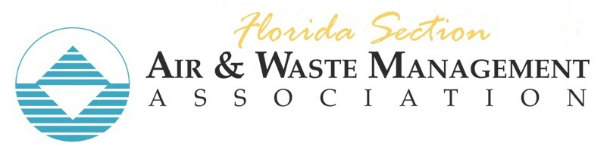](http://flawma.org/)

Join Us for the

**60th Annual Florida Section Conference & Exposition**

**Creating a Safe Harbor:  Balancing Regulation, Environment and Innovation**

 Conference Overview

The Florida Section is pleased to announce the **60th Annual Conference and Exposition being held on February 4th and 5th in Safety Harbor** at the Safety Harbor Resort & Spa on Tampa Bay. The event will offer a number of technical presentations by leaders in their fields, covering a broad range of the **hottest issues** with participation by representative regulatory agencies from around Florida including Florida Department of Environmental Protection (FDEP), leading consultants, and academia. The conference has been specifically designed to enhance opportunities for **networking and discussion** with experts in air, water, and waste.

Register now at: [2024 Florida Section AWMA Annual Conference](https://lp.constantcontactpages.com/ev/reg/yet8syd?source_id=e0868ac8-1332-46bc-9646-d835459e8706&source_type=em&c=eJnWXKDNP9FSIgjVu1IWdcGt6S_n4n_3bA7BnNIKq3JOGCLpj7n8Lg==)

ACCOMMODATIONS

Accommodations for this year’s event will be hosted by the Safety Harbor Resort & Spa.  Our conference room rate is $249/night plus parking and applicable taxes.   Book your rooms by clicking this [link](https://www.wyndhamhotels.com/trademark/safety-harbor-florida/safety-harbor-resort-and-spa/overview?_gl=1*3rsdr9*_ga*MTI3MTM4NDY3OC4xNjk2NDQyNjA5*_ga_9E1X88MX3P*MTcyMjk1Mzg0NC42OC4wLjE3MjI5NTM4NDQuMC4wLjA.&_ga=2.264992585.759547960.1722950939-1271384678.1696442609) to secure this room rate. Enter the check in and check out dates and then drop down the “Code Applied” button and enter the Group number 39V55P and click the CLOSE button at the bottom of that box.  Then hit the Update/Search Rooms button – your group rate will come up as available. The location and phone number are as follows:

 Safety Harbor Resort & Spa on Tampa Bay

105 North Bayshore Drive, Safety Harbor, FL 34695  
Reservations: [+1 888-237-8772](tel:18882378772) | [reservations@safetyharborresort.com](mailto:reservations@safetyharborresort.com)

 Conference Agenda

There is a robust technical program planned for this year with the preliminary agenda taking shape to address technical and regulatory air, water, and waste issues.  Topics and speakers planned for this year’s conference will include:

* Keynote Address – Leah Blinn, AWMA International President
* Air Regulations Update: Ambient Air Quality, Greenhouse Gas, Hazardous Air Pollutants with legal and regulatory updates and a status update ambient air quality updates. Moderator: Libby Eastman, CDM Smith
  + Jeff Koerner, FDEP
  + Alex Reeder, Trinity
  + Greg Munson, Gunster
  + Jason Waters, Environmental Protection Commission Hillsborough County
* Waste-to-Energy update with an assessment of emerging regulations, legal & regulatory concerns, and a case study on plant expansion. Moderator: Jason Gorrie, JMG Engineering, Inc.
  + Mike Carballa, Pasco County
  + David Robau, National Energy
  + Justin Roessler, Pasco County
  + Al Linero
* Waste Management Trends & Opportunities
  + Maria Cristina Lemes, Geosyntec
  + Jonathan Thorn, Eurofins
  + Robert A. Velasco
  + Tarek Abichou, FAMU-FSU
* Greenhouse Gas Trends & Opportunities, GHG reporting and climate impact trends. Moderator: Pradeep Halder, USF
  + Bill Karl, SWCA
  + Kent Merril, OSG
  + USF Student(s)
* Clean Energy & Emerging Technology, presenting an overview of research and projects in Florida. Moderator: Byron Burrows, TECO
  + John Kuhn, USF
  + Byron Burows, TECO
  + Michael Ballenger, Trinity
* Water Resource Management update with a reclaimed water & Aquifer Storage & Recharge case study and the legal and policy implications of flood resiliency
  + Shae Dunifon, JEA
  + Erin Deady, PA

**Interested in Sponsoring This Year’s Event?**

As a sponsor, you will ensure valued participation at the conference, which is important for a robust and meaningful discussion of emerging topics. The Section also uses sponsorship funds to provide scholarships to students who represent the Section at competitions held at the International Conference and for Section leadership training. As a sponsor, you will be given an opportunity to reach out to all of those attending through a display in the exhibition area, and the Section will recognize your company at the conference and through the Section’s website.

Please make plans to participate in the conference this year and to support the Florida Section as a sponsor. The Section sincerely appreciates your consideration of this request as sponsorship opportunities are still available!

Contact Joe Applegate at [japplegate@geosyntec.com](mailto:japplegate@geosyntec.com) for more information and to sign up as a sponsor at the conference.